
Lilly announces positive CHMP Opinion for Olumiant in adolescents (12 to <18 yrs) with severe AA
Company: Lilly  Drug: Olumiant (baricitinib, oral JAK 1/2 inhibitor) | Date: February 27th, 2026  Source(s): Press release, EMA
What happened:
- CHMP adopted a positive opinion recommending approval of Olumiant in adolescents (12 to <18 years) with severe alopecia areata (AA)

Impact (CI PoV): HIGH
- The positive opinion brings Olumiant closer to becoming the second approved therapy for adolescents with severe AA
- The approval is expected in late March or early April 2026 (30-45 days from the CHMP opinion for Type II variation submission)

Why it matters:
- The positive CHMP opinion positions Olumiant as the second therapeutic option for adolescents with severe AA, after Pfizer’s Litfulo (ritlecitinib, oral JAK3/TEC inhibitor), which is currently the only available option for use in the adolescent population with severe AA
- Both Litfulo and Olumiant are oral JAK class drugs with once daily dosing
  - Pfizer has an ongoing Phase 3 trial evaluating Litfulo in the pediatric population (6 to <12 years) with earliest approval expected in Q2 2028 in the US and EU, positioning it to become the first therapy approved for this age group
  - Lilly recently started enrolling for the 6-11 yrs cohort in BRAVE-AA-PEDS trial OUS
- Lilly has also submitted Olumiant to the FDA for approval in adolescents with severe AA, with a decision expected in 2H 2026; CI estimates approval in Q4 2026

Tell me more (CI Insights in blue italics):
- The data in the submission package includes results from the cohort of 12 to <18 years of the Phase 3 BRAVE-AA-PEDS study
  - It is an ongoing Phase 3 trial with three cohorts: cohorts 1&2 include adolescent ages 12 to <18 year and cohort 3 children ages 6 to <12 years
  - The 6 to <12 years cohort is expected to begin enrolling in 2026 in the US (CI estimates earliest approval in US and EU in Q4 2028)
- BRAVE-AA-PEDS Week 36 data:
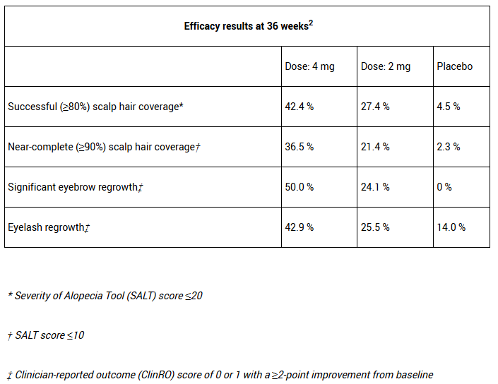

- 52-week data showed successful hair regrowth on the scalp, eyebrows and eyelashes in adolescent AA patients
- The safety profile in adolescents with AA aligned with that seen in trials involving children with jIA and moderate‑to‑severe AD

For questions, please reach out to:
 | Dermatology | Rheumatology | Gastroenterology
APEX (US/PCS) | Chanda Bhat | Bethany Christmann | Luke Versten
IMABI (International/ Affiliates) | Priti Anand | Irene Knorn | Priti Anand

Invite your colleagues to inVision | Manage Email Preferences | Unsubscribe

This document/email contains competitive intelligence collected via an approved competitive intelligence supplier working on behalf of AbbVie. We collect competitive intelligence consistent with industry standards and AbbVie policy. Not for field distribution. Please reach out to APEX/IMABI, Legal, or OEC teams with any questions.

